
woldia university

INSTITUTE OF TECHNOLOGY
School of Computing
Department of Software Engineering Internship Report
Name ID
1. THOMAS TESEMA ……………………………………………………..1302870
2. TILAHUN TAREKE ……………………………………………………..1306468
3. YARED KASA ……………………………………………………………..1303033
4.YOHANNES ALEMAYEHU …………………………………………..1303096

Department: Software Engineering
Internship Hosting Company: Ministry Of Innovation And Technology
Internship Duration: From March 8 – July 8/2025
Submitted To: Woldia University, Institute Of Technology, Software Engineering

Contents
Declaration 3
Acknowledgements 5
Executive Summary 6
Background Information of the Organization 7
Main Products or Services (Core business activities) 8
Main Customers or End Users (Market Focus and Target Users) 9
Government Ministries and Agencies 9
Organizational Structure (Organogram or description of hierarchy) 10
Work Flow in Each Program or Functional Unit (Processes in production, IT services, or business operations relevant to the company 11
Internship Experiences 17
2. Work Tasks You Executed 17
5. Measures, Solutions, and Recommendations to Address Problems 18
6. Skills and Knowledge Gained 19
Effective Communication 20
6. Leadership Skills 21
7. Work Ethics and Industrial Psychology Understanding 22
8. Entrepreneurship Skills 23
9. Interpersonal Communication Skills 24
9. Recommendation and Conclusion on Internship Experience 26
Recommendation 26
Conclusion 28
4.1. Summary of the Project 28
4.2. Statement of The Project and Justification 28
4.3. Objective of the project 29
4.3.1. General Objective 29
4.3.2. Specific Objective 29
4.4. Methodology (Approach, tools, and techniques applied) 29
4.4.1. Methodologies 29
4.4.2. Approaches 32
4.4.3. Tools 33
4.4.4. Techniques 34
4.5. Analysis, Results and Discussions 34
4.5.1. Analysis 34
4.5.2. Results 35
4.5.3. Discussion 35
4.6. Proposed Solution (Feasible and practical solutions) 36
4.6.1. Feasibility Studies 36
4.6.2. Scope and Limitation of the Project 38
4.6.3. Significance and Beneficiaries of the Project 40
4.6.3. Business Rules of the Proposed System 43
Business Rules of the Proposed Plan Monitoring and Evaluation System 43
Use case Diagram for the proposed System 50
Class Diagram for the Proposed System 51
ER Diagram for the proposed System 52
UI Prototypes 53
Part Five: General Conclusion and Recommendation 57
Overall Conclusion of Your Internship Journey 57
Final Recommendations for the Hosting Company and Future Interns 58

List of figures
Figure 1: use Case diagram 50
Figure 2: class diagram 51
Figure 3: ER Diagram 52

Declaration
We hereby declare that this project report is our own work and has not been copied or plagiarized from any source. All references used have been properly cited, and the work presented is a true representation of our efforts.
Thomas Tesema
Tilahun Tareke
Yared Kassa
Yohannes Alemayehu

Acknowledgements
First and foremost, our deepest gratitude goes to Almighty God. Without His will, guidance, and blessings, none of this would have been possible.
We would also like to sincerely thank the Ministry of Innovation and Technology (MINT) for hosting us during our internship. Special thanks go to MINT staff members, Ms. Fikrte and Ms. Wosen, for their support, guidance, and encouragement throughout our time there.
In addition, we are grateful to the fellow paid internship students working alongside us at MINT. Their collaboration, friendship, and shared experiences made our time more productive and enjoyable.

Executive Summary
This report presents a summary of a four-month internship completed at the Ministry of Innovation and Technology (MINT), a federal institution committed to fostering technological innovation, digital transformation, and ICT development in Ethiopia. The internship provided hands-on experience in a government-led technology environment and allowed us to contribute to a real-world software development project.
As a team of four interns, we were tasked with the end-to-end development of a Plan Evaluation and Monitoring System, aimed at improving internal project tracking and performance evaluation within the organization. Under the guidance of staff members Ms.Fikrte and Ms. Wosen, we independently carried out all phases of the Software Development Life Cycle (SDLC).
Throughout the internship, we strengthened both our technical and professional capabilities. Technically, we improved our skills in system analysis, interface design, backend development, and deployment techniques. Professionally, we developed essential competencies in project planning, team collaboration, time management, and reporting. Close mentorship from MINT staff further enriched our understanding of how digital systems can support public sector innovation and transparency.
A major achievement of our internship was the successful development and deployment of the Plan Evaluation and Monitoring System prototype, which fully met the initial functional requirements and received positive feedback from our supervisors. Successfully completing all key phases of the Software Development Life Cycle (SDLC) as a focused team of four showcased our strong collaboration, technical capability, and commitment to delivering a meaningful and functional solution.
In conclusion, this internship at MINT was a highly impactful experience that enabled us to apply our academic training to a meaningful government project, while also preparing us for future challenges in the field of information technology and systems development.

Background Information of the Organization
Ministry Of Innovation And Technology (MinT) was established in December 1975 by proclamation No.62/1975 as a Science and Technology commission.
Science and Technology Commission (1975 - 1994)
- The Commission was re-established in March 1994 by Proclamation No.91/1994.
- Furthermore, the commission went into its 3rd phase of re-institution on the 24th of August 1995 by Proclamation No.7/1995 as Science and Technology Agency
Science and Technology Agency (1994-2008)
- 4th phase of re-institution on September 29, 2008 by proclamation No.601/2001 as a Ministry. After the year 2011 EC Ministry of Science and Technology changed into ministry of Innovation and Technology by combining the then Ministry of Science and Technology and Ministry of Communication and Information Technology.
Vision of the Organization
- Build a country that is conducive for job and wealth creation through technology and innovation.
Mission of the Organization
- The Mission also to ensure the sustainability of the country’s development by creating an environment in which innovation systems are implemented.
- Creating an environment for the digital economy of the country
- Building the capacity to increase the competitiveness of the country's technology industry development

Main Products or Services (Core business activities)
MInT is a government ministry, so its outputs are more in policy, infrastructure, programs, regulation, and public service platforms, rather than commercial products. But there are many concrete projects and services. Major areas include:
Area
  What MInT does or what it delivers
Policy, Strategy, Regulation | - Develops national policies on science, technology, innovation; regulation of ICT or communications; policy for startups; strategy for digital economy.
Digital Infrastructure & Platforms | - Digital ID programs like Fayda for identity.  - One stop digital service centers, e service portals Mesob that bundle many public services digitally.  - National Business Portal, e government services online.
Capacity Building or Skills Development | - Training programs like 5 Million Coders’ Initiative to train citizens in digital or computational skills.  - Incubation or tech hubs across regions.
Innovation Ecosystem Support | - Supporting start up.  - Research and development institutes under MInT, such as the Ethiopian Biotechnology Institute Bio and Emerging Technology Institute.  - Science museum, awareness or public science infrastructure.
Digital Government / Public Service Digitalization | - Digitizing many government services like licensing, IDs, tax.  - Digital payments including linking government services to e-payments.

Main Customers or End Users (Market Focus and Target Users)
As a government institution, the Ministry of Innovation and Technology primarily serves a broad spectrum of public and private stakeholders across Ethiopia. The main beneficiaries and target users include:

Government Ministries and Agencies
MInT provides policy guidance, digital tools, and ICT infrastructure support to other government institutions to improve service delivery and interconnectivity.
Research Institutions and Universities
These organizations collaborate with MInT for research funding, innovation promotion, and technology transfer initiatives.
Private Sector and Startups
The Ministry supports innovation-driven enterprises, tech startups, and industrial sectors through incubation centers, grants, and regulatory frameworks.
Regional Bureaus and Local Administrations
MInT extends its services through regional innovation and technology bureaus to ensure nationwide implementation of innovation and digital policies.
International Partners
Global development partners, such as the UNDP, UNESCO, World Bank, and African Development Bank, work with MInT on projects related to digital transformation, innovation ecosystems, and capacity building.
Citizens and Society at Large
The ultimate end-users of MInT’s initiatives are Ethiopian citizens, who benefit from improved access to digital services, e-government systems, and innovation-driven economic opportunities.

Organizational Structure (Organogram or description of hierarchy)
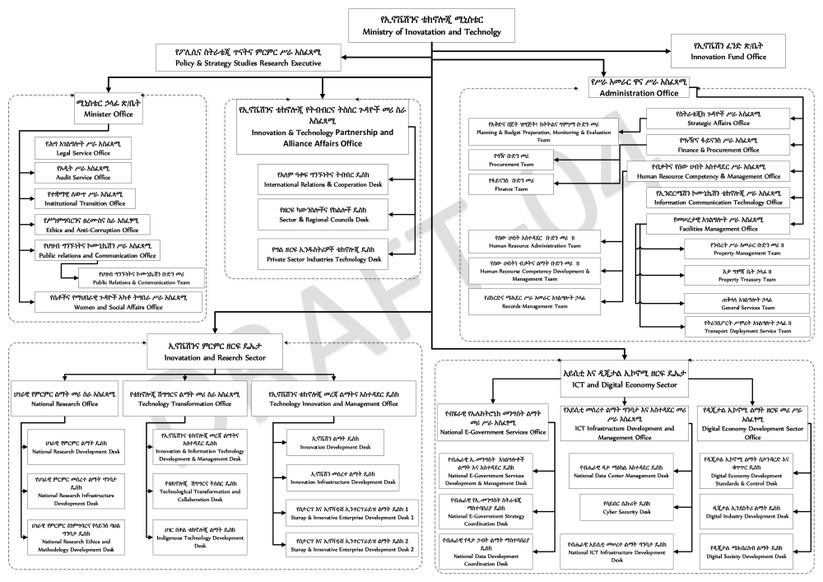

Work Flow in Each Program or Functional Unit (Processes in production, IT services, or business operations relevant to the company
The Ministry of Innovation and Technology (MInT) operates through several major functional units, each with defined mandates and procedures that collectively contribute to achieving the Ministry’s national objectives. The workflow within each unit is systematic, transparent, and interlinked, ensuring effective coordination between internal departments and external partners such as other government ministries, regional bureaus, and international organizations.
Each directorate performs specialized tasks from policy formulation to project implementation while maintaining cross-functional collaboration through regular meetings, reporting mechanisms, and integrated information systems.
a. Policy and Planning Directorate
This directorate plays a strategic leadership role in shaping the national science, technology, and innovation (STI) agenda. It is responsible for policy formulation, planning, coordination, and performance monitoring.
Inputs
- National development policies such as the Home grown Economic Reform Agenda and Ten-Year Development Plan.
- Sectoral strategies from ministries related to education, industry, agriculture, and ICT.
- Stakeholder consultations involving universities, research institutes, private sector actors, and regional innovation bureaus.
- Data and reports from past projects and studies that inform evidence-based policymaking.
Processes:
- Needs Assessment: Identify emerging issues, technology gaps, and innovation priorities at national and regional levels.
- Policy Drafting: Develop draft policies, strategies, and guidelines through expert committees and technical working groups.
- Consultation and Review: Conduct stakeholder workshops and validation forums to gather feedback.
- Impact Analysis: Evaluate the potential social, economic, and environmental impacts of proposed policies.
- Approval Process: Finalize policy drafts and submit them to the Council of Ministers for official endorsement.
- Implementation Coordination: Guide and monitor the rollout of policies across institutions.
- Monitoring and Evaluation (M&E): Track performance indicators and assess implementation outcomes.
Outputs:
- National Science, Technology, and Innovation (STI) Policies.
- Digital Transformation Strategy Frameworks (e.g., Digital Ethiopia 2025).
- Implementation manuals, progress reports, and policy briefs.
- Midterm and end-of-year performance evaluation reports.
b. Innovation and Research Directorate
The Innovation and Research Directorate is the operational backbone for promoting innovation culture, supporting research excellence, and fostering technology transfer between academia and industry.
Inputs:
- Research proposals and innovation projects submitted by universities, startups, and research institutions.
- Applications for research funding or innovation grants.
- Government priority areas and innovation focus sectors (e.g., biotechnology, renewable energy, ICT, agriculture, and manufacturing).
- Data from previous innovation programs and project evaluations.
Processes
- Call for Proposals: Announce innovation grant opportunities and invite eligible institutions or individuals to apply.
- Screening and Evaluation: Technical committees evaluate proposals based on relevance, feasibility, and alignment with national priorities.
- Approval and Funding: Selected projects receive funding and technical support for implementation.
- Project Monitoring: Conduct regular site visits, progress reporting, and midterm evaluations.
- Knowledge Sharing: Organize innovation fairs, exhibitions, and research dissemination workshops.
- Technology Transfer: Facilitate partnerships between innovators, industries, and investors for commercialization.
- Final Reporting: Collect final reports, assess outcomes, and document lessons learned for future planning.
Outputs
- Funded research and innovation projects.
- Annual national innovation awards and exhibitions.
- Published research outputs, patents, and technology prototypes.
- Comprehensive monitoring and evaluation reports.
c. ICT and Digital Transformation Directorate
This directorate is responsible for managing national ICT programs, overseeing e-government systems, and coordinating Ethiopia’s digital transformation efforts. It serves as the technical engine of MInT, linking policy with practical implementation.
Inputs
- Requests and project proposals from ministries, agencies, and regional bureaus seeking ICT solutions.
- ICT infrastructure needs assessments and cybersecurity risk analyses.
- National standards, data protection regulations, and interoperability frameworks.
- Feedback from users and technical partners on system performance.
Processes
- System Requirement Analysis: Assess client ministry needs for e-services or ICT systems.
- Design and Development: Prepare system architecture, software design, and infrastructure layout.
- Testing and Quality Assurance: Conduct system testing to ensure reliability, security, and performance.
- Deployment: Install and configure systems in production environments.
- Maintenance and Support: Provide continuous technical assistance, system updates, and performance monitoring.
- Cybersecurity Management: Implement preventive measures, risk assessment, and incident response mechanisms.
- Integration and Interoperability: Ensure ICT systems work seamlessly with national databases and e-government platforms.
Outputs:
- Functional e-government platforms and portals.
- National data centers and cloud infrastructure services.
- Strengthened cybersecurity frameworks and digital governance systems.
- Digital tools, applications, and infrastructure for public sector modernization.
d. Human Resource and Capacity Building Directorate
This directorate ensures that MiNT and its affiliated institutions have a competent, skilled, and motivated workforce capable of driving innovation and digital transformation.
Inputs
- Training needs assessments from departments and subordinate institutions.
- Human resource development plans and performance appraisals.
- Government HR policies and capacity-building frameworks.
- Inputs from international partners offering technical assistance or training programs.
Processes
- Needs Assessment: Identify competency gaps within technical and administrative staff.
- Training Design and Development: Develop tailored training programs and select trainers or partner institutions.
- Implementation: Conduct workshops, seminars, online training, and exchange programs.
- Evaluation: Measure the effectiveness of training through feedback, post-training assessments, and performance analysis.
- Career Development Planning: Design professional growth paths, succession planning, and incentive schemes.
- Documentation: Maintain detailed training records and HR statistics.
Outputs
- Enhanced workforce skills in ICT, innovation management, and research coordination.
- Certified professionals in key technical and managerial domains.
- Improved employee performance and institutional productivity.
- Comprehensive HR reports and capacity development frameworks.
e. Finance and Administration Directorate
The Finance and Administration Directorate oversees financial management, logistics, procurement, and general services. It ensures transparent, efficient, and accountable resource utilization across the Ministry.
Inputs
- Annual budget proposals from directorates and subordinate agencies.
- Procurement requests and project financial plans.
- Government financial regulations and audit guidelines.
- Expenditure reports and procurement records.
Processes
- Budget Planning: Consolidate departmental budget requests and align them with the Ministry’s priorities.
- Resource Allocation: Distribute financial resources to approved projects and programs.
- Procurement Management: Handle tender processes, supplier evaluations, and contract awards in line with national procurement laws.
- Expenditure Tracking: Monitor fund disbursement and project expenditures.
- Financial Reporting: Prepare monthly, quarterly, and annual financial statements.
- Audit and Compliance: Facilitate internal and external audits to ensure transparency and accountability.
- Asset Management: Manage physical and digital assets including office facilities, vehicles, and IT equipment.
Outputs
- Detailed financial statements and budget performance reports.
- Procurement documentation and compliance records.
- Efficient resource allocation and financial transparency.
- Timely audit reports and corrective action plans.
f. Communication and Public Relations Office
The Communication and Public Relations (PR) Office manages MInT’s internal and external communication strategies, public outreach, and stakeholder engagement. It ensures that the Ministry’s activities are visible, transparent, and accessible to the public and partners.
Inputs
- Press releases, information requests, and project updates from various directorates.
- Communication materials such as newsletters, reports, and media briefs.
- Feedback from citizens, partners, and the media.
Processes
- Information Gathering: Collect updates and success stories from projects and departments.
- Media Relations: Organize press conferences, interviews, and media briefings to communicate major achievements.
- Content Development: Prepare publications, newsletters, brochures, and social media updates.
- Public Awareness Campaigns: Design and launch outreach programs promoting innovation and technology adoption.
- Stakeholder Engagement: Coordinate communication with government offices, donors, and innovation stakeholders.
- Event Management: Organize conferences, exhibitions, and national innovation festivals.
- Feedback and Reputation Management: Monitor media coverage and respond to misinformation or public concerns.
Outputs:
- Regular press releases and official publications.
- Increased public awareness of MiNT programs and policies.
- Strong institutional brand and improved visibility in local and international forums.
- Communication performance reports and stakeholder feedback summaries.
Internship Experiences
1. Section of the Company You Worked In and Why
We were assigned to the Digital Innovation and ICT Department at the Ministry of Innovation and Technology which is responsible for planning, implementing, and evaluating digital projects within government institutions. As software engineering students, this section of the company aligned perfectly with our academic background, giving us the opportunity to apply technical knowledge in real government-based projects and understand how innovation is applied in the public sector.

2. Work Tasks You Executed
- Our main task was the development of a Plan Evaluation and Monitoring System. This included:
- Conducting requirement gathering from department stakeholders.
- Creating system design documents (UML diagrams, data models).
- Implementing the system using appropriate programming tools.
- Testing the prototype and deploying it internally.
- We also prepared technical documentation and presented progress reports to our supervisors.
3. Engineering Methods, Tools and Techniques Used
We followed the Software Development Life Cycle (SDLC) methodology, covering key stages such as requirement analysis, system design, implementation, testing, and deployment. For the front-end, we used React.js to build a dynamic and responsive user interface. On the backend, we developed RESTful(Representational State Transfer) APIs using Node.js with the Express.js framework. We used MongoDB as our primary NoSQL database to handle and store project-related data efficiently. For system modelling and documentation, we used EdrawMax to create UML diagrams such as use case, class, and activity diagrams. This modern full-stack approach enabled us to build a scalable and maintainable web application that met the functional requirements of the project.
4. Challenges and Problems Encountered
One of the major challenges we encountered during the internship was the unclear and incomplete nature of the project requirements in the early stages. Due to the limited technical background of some stakeholders, gathering detailed and precise system needs required multiple discussions and clarifications. This affected the initial planning and delayed progress in the requirement analysis phase.
In addition to technical challenges, we also faced logistical limitations. We did not have a dedicated or isolated working space and were required to share a classroom with other students, which often disrupted focus and productivity. The overall shortage of space and facilities impacted our ability to work efficiently, particularly during collaborative tasks like group discussions, code reviews, and testing.
Furthermore, we experienced some inequity in access to services provided to regular staff. For instance, the cafeteria system offered a 50% discount to company employees, but this benefit was not extended to us as interns. This highlighted a gap in intern support and inclusivity within the organization’s structure.

5. Measures, Solutions, and Recommendations to Address Problems
To overcome the challenge of unclear and incomplete project requirements, our team took the initiative to conduct several follow-up meetings with key stakeholders to clarify expectations and gather missing details. We also created low-fidelity mockups and flowcharts to help non-technical users visualize the system, which made communication easier and reduced misunderstandings. All changes and new inputs were carefully documented to ensure alignment throughout the development process.
Regarding the shortage of dedicated working space, we adapted by adjusting our schedule to make use of quieter hours when the shared classroom was less occupied. However, to ensure uninterrupted collaboration and focus, we also held additional work sessions at public libraries, including Abrehot Library and Wemezeker Public Library. These locations provided a more conducive environment for planning, coding, and discussions. To stay organized and connected, we relied on digital tools such as GitHub for version control, Google Docs for shared documentation, and messaging platforms for real-time coordination, which helped us maintain productivity despite the spatial limitations.
To address the issue of limited facilities and lack of cafeteria access, we brought our own meals or made arrangements outside the company, though it was inconvenient. We recommend that the organization consider providing equal access to basic services like the cafeteria for interns, or at least offering a reasonable discount. This would improve intern motivation and reflect greater inclusion.
As a general recommendation, we suggest that future internship programs include a clear on boarding process with well-defined project requirements and designated workspaces for interns. Doing so would not only improve productivity.

6. Skills and Knowledge Gained
- Practical Skills
During the internship, I gained several practical, hands-on skills that directly enhanced my technical competency in real-world environments. Most notably, I became proficient in using the MERN stack (MongoDB, Express.js, React.js, Node.js) to build a full-fledged web application. I learned how to:
- Set up and configure the backend server using Node.js and Express.
- Build dynamic and interactive front-end interfaces using React.js components.
- Integrate MongoDB for efficient, document-based data storage and retrieval.
- Handle API routes, manage requests, and implement CRUD operations securely.
- Perform basic deployment using local environments and test user flows.
- Use and collaborate with the team members using version control method called Github.
Theoretical Knowledge
The four month internship also helped solidify many academic concepts learned in class. Among those are:
- Database normalization principles to structure collections in MongoDB for optimized data retrieval.
- Software Development Life Cycle (SDLC) methodologies to organize our workflow into clear stages. Those are requirement gathering, design, implementation, testing, and deployment.
- Concepts of Object-Oriented Programming (OOP) while developing modular backend components.
- System modelling techniques, such as creating UML diagrams using EdrawMax, to visualize system workflows and interactions.
For example, the use case and class diagrams drawn for this project are directly based on system analysis principles taught in software engineering courses.
Teamwork Skills
- Working as part of a four-member team thaught us different teamwork skills that enable as to collaborate each member with the team members and the supervisors.Regarding with those skills we developed:

Effective Communication
Sharing ideas, updates, and issues clearly and respectfully. In daily stand-ups or group chats, we'd learned how to clearly express technical progress or blockers, listen to teammates, and respond constructively.
Collaboration and Pair Programming
Working closely with others to solve problems or build features. We mostly paired up to debug code, integrate APIs, or merge frontend and backend components. This thought how to share responsibility, compromise, and learn from peers.
Receiving and Applying Feedback
Accepting critiques on our work and using them to improve on different quality aspect. Through code reviews or team feedback sessions, we'd get used to constructive criticism and understand how to implement suggestions without taking them personally. Also Offering helpful suggestions to improve others’ work without being critical or rude.
Responsibility and Accountability
Completing our tasks on time so others can do their part. in a team workflow, one delay can block others. This teaches us the importance of meeting deadlines, updating the team, and owning our part of the work.

6. Leadership Skills
Task Delegation
Assigning specific tasks to team members based on each team member strengths, expertise, or learning goals. During the internship, we have identified who was strongest in frontend, backend, project management or testing and allocated tasks accordingly. This teaches us how to optimize team productivity and reduce redundancy.
Project Coordination
Managing timelines, aligning team efforts, and ensuring the project progresses smoothly. Keeping track of progress, organizing team check-ins, and adjusting workloads based on deliverables helped us to build planning and time management skills.
Technical Decision-Making
Making informed choices about technologies, frameworks, libraries, or architectures. We have chosen between MongoDB vs. MySQL, REST vs. GraphQL, Reactjs vs. Nextjs or implemented authentication strategies. Leadership involves making those calls with justification and guiding others through the implications.
Mentorship and Support
Informally guiding junior or less-experienced teammates. Even if we most are junior, helping one another on less awarded side debug, explaining concepts or reviewing code builds coaching and mentoring skills.
Communication and Feedback
Clear, constructive communication with teammates and possibly supervisors or clients.
Regular updates, peer reviews, giving/receiving code feedback, or presenting project milestone; once in a week all build our ability to communicate as a leader.

7. Work Ethics and Industrial Psychology Understanding
Being part of a structured government institution like MINT exposed us to the importance of strong work ethics and understanding the formal workplace culture. We learned that beyond technical skills, maintaining professional behavior and responsibility is critical for success in real-world environments. We bring the following Experiences:
Punctuality and Time Discipline
We were expected to begin our workday at a specific time, and consistently arriving early or on time helped us form reliable habits.
Respect for Hierarchy
We observed how communication and approvals flowed through formal channels. For instance, we always reported first to our immediate supervisors (Ms. Fikrte or Ms. Wosen) before escalating any issue to other staff.
Professional Conduct
During meetings, we learned to listen more than speak, to take notes carefully, and to avoid interrupting especially when senior officials were involved. We also practiced how to respond constructively to criticism.
Adaptability to Organizational Behavior
Sometimes, decisions in the institution were influenced by administrative policies rather than purely technical factors. This helped me appreciate how psychological factors like motivation, leadership style, and bureaucracy affect how large organizations operate.

8. Entrepreneurship Skills
Entrepreneurship skills aren't only about starting a business but they also involve creativity, problem solving, initiative, innovation, and thinking ahead, even within a structured environment like a government office. Despite the structured nature of MINT, we encountered several opportunities to think independently and make improvements beyond what was initially asked of us. The following are list of skills what we grasped during the internship journey:
Problem-Solving Skills
Entrepreneurs are problem-solvers. While working on full-stack applications, we have encounted bugs, design issues, or performance problems. Learning to debug, optimize, and find efficient solutions mirrors the kind of problem-solving needed in entrepreneurship.
Critical Thinking and Decision-Making:
Choosing between different tools, frameworks, or design patterns requires thoughtful analysis. This ability to weigh pros and cons and make informed decisions is critical in running a business.
Product Development Mindset
Building user-focused applications teaches us how to think like a product developer:
- What does the user need?
- How should the UI/UX flow?
- What features are essential?
This mindset aligns with creating Minimum Viable Products (MVPs) and iterating quickly which is key in entrepreneurship.
Communication and Collaboration
Startups business and dev teams require strong communication; both verbal and nonverbal or written. During the internship we explained our ideas to teammates or mentors, participate in stand-ups, code reviews, and discussions. This mirrors the communication needed to pitch to investors, lead a team, or negotiate with stakeholders.
Project and Time Management:
Interns often juggle multiple tasks like building features, fixing bugs, meeting deadlines. Learning to manage time, set priorities, and deliver on schedule is exactly what entrepreneurs must do when building and launching products under pressure.
Customer or User-Centric Thinking:
We have received feedback from stakeholders and our supervisors on our application. So learning to accept feedback, iterate based on user needs, build features that actually solve user problem and so on are essential for creating a successful product and business.
Creativity and Innovation
We have encouraged to propose new features or improvements. Thinking creatively about user experience or tech solutions helps us to develop the innovative mindset entrepreneurs need to disrupt industries.

9. Interpersonal Communication Skills
Throughout the internship, I had regular interactions with fellow interns, supervisors, and non-technical staff. This setting helped me strengthen my interpersonal and cross-functional communication skills.
Best Experiences we gained in the course of internship :
Active Listening
We have often need to listen carefully to mentor instructions, team feedback, client or user requirements. This skill ensures we fully understand tasks before starting and helps avoid misunderstandings.
Clarity in Verbal Communication
Whether in team meetings or stand-ups, we have practiced explaining:
- What we are working on?
- What blockers we face?
- What progress we’ve made?
Speaking clearly and concisely is essential for effective teamwork.
Team Collaboration
We have often worked with other developers, designers, or testers. Collaborating on shared repositories, planning features together, or resolving merge conflicts teaches you how to work as part of a cohesive team.
Confidence in Presenting Ideas
We have been asked to present the project progress to the team, explain our approach in meetings, suggest new features or improvements during the process. This approach helps develop our ability to speak up confidently and defend our ideas respectfully..
Networking and Building Rapport
Building professional relationships with mentors, teammates, and other interns helps us to improve collaboration, create future career opportunities, make the internship more enjoyable. This is foundational for long-term success in any industry.
Feedback Handling
During weekly updates, our supervisors gave us constructive feedback. I learned to receive criticism professionally and respond with adjustments instead of taking it personally.

9. Recommendation and Conclusion on Internship Experience
The four month internship at the Ministry of Innovation and Technology (MINT) was an invaluable and transformative experience. It marked a critical shift from academic learning to hands-on application in a real-world government setting. Being part of the Digital Innovation and ICT Department, we engaged directly with the development of the Plan Evaluation and Monitoring System which is a project that exposed us to the full Software Development Life Cycle (SDLC) and allowed us to apply the MERN stack (MongoDB, Express.js, React.js, Node.js) in a practical and impactful way.
Our tasks included requirement gathering, system design, coding, testing, and deployment all of which deepened our technical knowledge and broadened our understanding of how software engineering contributes to public sector efficiency. Beyond programming, the internship cultivated key soft skills such as teamwork, leadership, interpersonal communication, project management, and professional ethics.
The experience also strengthened our entrepreneurial mindset. We learned to take initiative, identify and solve real problems, and communicate effectively with both technical and non-technical stakeholders. Despite several challenges such as lack of workspace, limited facilities for interns, and unclear initial requirements we remained resilient and resourceful. These situations helped us grow not just as developers, but as adaptable and future-ready professionals.
Recommendation
As we reflect on our four-month internship experience at the Ministry of Innovation and Technology (MINT), it is clear that this opportunity was both enriching and educational. We were able to apply our academic knowledge in real-world government projects, particularly through the development of the Plan Evaluation and Monitoring System. While the internship allowed us to grow technically and professionally, it also exposed us to various workplace challenges, such as limited access to resources, unclear project requirements, and logistical constraints.
These challenges, though sometimes frustrating, became valuable learning experiences. They taught us the importance of adaptability, communication, teamwork, and initiative; qualities that extend far beyond the technical scope of software development. Based on our journey, we have formulated the following recommendations aimed at improving the internship experience for future participants and enhancing the support systems within the organization.
For Future Interns:
Take Initiative Early
Don’t wait for tasks; actively seek problems to solve and ask questions. Proposing ideas and improvements will help them stand out and grow faster.
Adapt to Uncertainty
Expect ambiguity in requirements and resource limitations. Use it as a chance to improve your problem-solving, flexibility, and resilience.
Communicate Clearly and Often
Regularly update your team and supervisors. Don’t hesitate to clarify tasks or ask for help when needed. Communication is as important as coding.
Document Everything
Keep detailed notes of meetings, changes, and decisions. This not only keeps your project aligned but also makes your work more professional.
Balance Technical and Soft Skills
Focus not only on coding but also on improving your teamwork, time management, collaboration, and leadership abilities these will serve you in every future role.
For the Ministry of Innovation and Technology (MINT)
Provide Dedicated Workspace for Interns
A quiet, designated area would significantly improve focus, productivity, and the quality of collaborative work among interns.
Offer Equal Access to Basic Intern Benefits
Extending services like cafeteria discounts or workspace access to interns would boost morale, motivation, and a sense of inclusion.
Improve Onboarding and Requirement Clarity
Providing a structured onboarding process with clear documentation and expectations would help interns contribute more effectively from the beginning.
Encourage Continued Mentorship
Assigning a consistent mentor or supervisor throughout the internship period would provide better guidance and support for learning and growth.
Conclusion:
This internship has had a profound impact on our academic and professional development. It not only reinforced our interest in software development and digital transformation but also gave us the confidence to handle real-world technical and workplace challenges. We are proud of what we achieved as a small team and grateful for the opportunity to contribute to a meaningful government initiative. The experience has equipped us with the mindset, skills, and motivation to take on future roles in the tech industry with greater responsibility and purpose.

4.1. Summary of the Project
This project proposes a web-based Project Plan Monitoring and Evaluation System for the Ministry of Innovation and Technology (MInT). The system is designed to improve the efficiency, transparency, and accuracy of monitoring and evaluating ongoing and completed projects within the ministry. It enables users to input project data, track progress through dashboards, and generate performance reports. The system was developed using open-source technologies such as HTML, CSS, JavaScript, Node.js, and MongoDB, ensuring affordability and scalability. The solution enhances decision-making and supports MInT’s mission of promoting effective innovation management across Ethiopia.

4.2. Statement of The Project and Justification
The Ministry of Innovation and Technology (MiNT) oversees numerous innovation and research projects across the country. However, the current method of monitoring and evaluating these projects is largely manual, paper-based, and fragmented, leading to delays, data inaccuracy, and limited transparency. Project progress reports are often inconsistent, making it difficult for administrators to assess performance or make timely decisions.
Therefore, developing an automated Project Plan Monitoring and Evaluation System is justified to enhance project visibility, ensure real-time tracking, and support evidence-based decision-making within the Ministry.

4.3. Objective of the project

4.3.1. General Objective
- The general objective is to develop web-based plan monitoring and evaluation system.

4.3.2. Specific Objective
- To create a centralized platform for monitoring and evaluating the effectiveness of innovation and technology programs.
- To provide real-time data and performance metrics on government-backed initiatives, enabling informed decision-making.
- To enhance transparency and accountability in the management of public funds allocated to technology and innovation projects.
- To facilitate data-driven insights for future policymaking and improve the allocation of resources towards high-impact initiatives.
- To insert manual planned data to the system and control online

4.4. Methodology (Approach, tools, and techniques applied)

4.4.1. Methodologies
a. System Development Methodology : Agile SDLC
The Agile System Development Life Cycle (SDLC) methodology was adopted for the overall system development process. This approach emphasizes iterative development, team collaboration, and continuous feedback from end-users. Instead of completing the system in one long phase, the project was developed in short cycles, with each sprint delivering a functional component such as project registration, progress tracking, or reporting modules.
At the end of every sprint, feedback from MiNT project officers and IT staff was gathered to refine the next iteration. This approach ensured that the final system met the ministry’s requirements and could adapt to changes throughout development.
b. Data Gathering Methodologies
Data gathering methodologies were used to collect both qualitative and quantitative information for requirement analysis and system design.
A mixed-method approach was applied, combining multiple techniques to ensure data accuracy and completeness.
Interviews:
Conducted with project managers, evaluation officers, and IT experts at MiNT to understand their challenges and expectations for the new system.This method provided in-depth qualitative insights into workflow issues and user preferences.
Questionnaires:
Distributed to staff across various departments to collect quantitative data on project reporting frequency, existing bottlenecks, and system needs.The responses helped prioritize essential features such as dashboard summaries and automated reports.
Observation:
On-site observations were conducted to study how current project tracking and evaluation processes were handled manually.This revealed inefficiencies such as data redundancy, late submissions, and communication gaps.
Document Review:
Existing project forms, reports, and templates were reviewed to ensure that the new system’s database and reporting structure matched MiNT’s existing documentation standards.
c. System Design Methodologies
The Object-Oriented Design (OOD) and Model-Based Design methodologies were employed during system design.
These methods helped translate user requirements into logical and visual models that guided development.
Use Case Modelling
Used to describe how different users (administrators, project officers, evaluators) interact with the system.Each use case illustrated a specific functionality such as plan and goal registration, monitoring, or report generation.
Data Flow Diagrams (DFDs)
Used to visualize the flow of data between the system’s components from user input to storage and output generation.
Entity Relationship Diagrams (ERDs)
Used to design the database structure and show relationships among entities such as Goals, KPIs, KRAs, User and Reports.
User Interface Design:
Developed using Figma, focusing on simplicity, usability, and accessibility. The design followed modern web standards to ensure responsiveness and intuitive navigation.
d. System Development Methodologies (Implementation Phase)
The actual coding and system implementation followed modular development principles under the Agile model. Each module was developed and tested independently before integration.
The development stack included:
Frontend: HTML, CSS, JavaScript, React.js
Backend: Node.js with Express.js
Database: MongoDB
Version control was maintained through Git and GitHub, ensuring smooth collaboration and code management among team members.
e. System Testing Methodologies
Testing methodologies were applied to ensure that the developed system was functional, reliable, and user-friendly before deployment.
Unit Testing
We have Verified that each individual component like login module, goal, KPI and KRA registration form, report generator performed as expected.
Integration Testing
Checked whether the different modules worked together properly once combined.
System Testing
Evaluated the complete system for performance, functionality, and error handling.
User Acceptance Testing (UAT)
Conducted with selected MiNT staff, the plan monitoring staff in the institution, to ensure the system met real operational requirements and was easy to use.
Security and Performance Testing
Assessed the system’s ability to protect data and perform efficiently under multiple user loads.

4.4.2. Approaches
A mixed-method research approach was employed in the development of the Project Plan Monitoring and Evaluation System for the Ministry of Innovation and Technology (MiNT). This approach combined both qualitative and quantitative research techniques to ensure a comprehensive understanding of the problem domain, system requirements, and user expectations.
The qualitative approach was primarily used to explore the experiences, challenges, and workflow patterns of MiNT staff involved in project management. Through interviews, discussions, and observations, qualitative insights were obtained about the inefficiencies of the existing manual system, the types of reports generated, and the decision-making challenges faced by project officers. These insights guided the design of user-friendly interfaces and functional modules that aligned with real operational needs.
The quantitative approach, on the other hand, focused on the analysis of numerical and measurable data related to MInT’s project activities. Data such as the number of projects handled annually, average reporting time, frequency of delays, and resource utilization were collected and analysed. This helped quantify the impact of current inefficiencies and provided concrete evidence to justify the need for an automated system.
By integrating both qualitative and quantitative methods, the mixed approach ensured that both human-centered insights and data-driven findings were incorporated into system development. This combination made the solution technically sound, contextually relevant, and operationally feasible for MInT’s digital transformation objectives.

4.4.3. Tools
The system was designed, developed, and tested using modern, open-source technologies to ensure cost-effectiveness, scalability, and maintainability.
Frontend: HTML, CSS, JavaScript, and React.js were used to create an interactive, responsive, and user-friendly interface.
Backend: Node.js and Express.js were applied for server-side development to manage user requests, authentication, and data communication.
Database: MongoDB was used as the primary data storage system to handle large volumes of project-related data efficiently.
Design and Prototyping: Figma was employed to design and visualize user interface layouts before development.
Version Control: Git and GitHub were used for source code management and collaborative development.
These tools were selected based on their compatibility, flexibility, and suitability for web-based project management systems.

4.4.4. Techniques
Several techniques were applied during different stages of the system development process:
Requirement Analysis: Conducted through user interviews, observation, and document analysis to identify the functional and non-functional requirements of the system.
System Modelling: Use case diagrams, data flow diagrams (DFDs), and entity-relationship diagrams (ERDs) were used to represent workflows, data movement, and database structures.
Testing: The system underwent unit testing, integration testing, and user acceptance testing (UAT) to verify that each component functioned as expected and that the final system met user requirements.
Evaluation: User feedback was gathered after testing to assess usability, performance, and reliability, leading to iterative refinements during subsequent Agile sprints.

4.5. Analysis, Results and Discussions

4.5.1. Analysis
The analysis phase involved examining the existing project monitoring and evaluation practices within MInT. The study revealed that project tracking was primarily conducted through manual documentation, spreadsheet records, and email-based reporting. This method was prone to delays, data duplication, and lack of real-time visibility.
The functional requirements identified included:
- Project registration and categorization by department.
- Real-time progress tracking and performance indicators.
- Automatic generation of progress reports and evaluation summaries.
- User access control and authentication.
- Dashboard visualization for administrators and managers.
The non-functional requirements focused on system usability, security, data integrity, and scalability to accommodate multiple concurrent users and large project data.

4.5.2. Results
The implementation of the proposed system resulted in a fully functional web-based platform that enables project managers and ministry staff to efficiently record, monitor, and evaluate project activities.

Main area results or outcomes include:
- Successful automation of project registration, progress tracking, and reporting.
- A dynamic dashboard that provides real-time insights into project performance.
- Improved data accuracy and reduced reporting delays.
- Secure role-based access for different users (administrators, project officers, and evaluators).
- Integration of performance indicators to facilitate data-driven decision-making.
- The system was tested with sample project data, and user feedback indicated that it was intuitive, responsive, and met the operational needs of the Ministry.

4.5.3. Discussion
The analysis and implementation results demonstrate that the system effectively addresses the challenges previously faced by MiNT in managing project plans and evaluations.
The automation of data entry and reporting eliminated redundant manual processes, while the centralized database enhanced information consistency and accessibility.
The Agile approach allowed continuous collaboration and adaptation, ensuring that the system aligned closely with user expectations. The feedback collected during testing confirmed that the new system improved efficiency, reduced workload, and enhanced transparency in monitoring and evaluation activities.
Overall, the Project Plan Monitoring and Evaluation System provides a feasible, practical, and sustainable solution that supports MiNT’s broader goal of digital transformation and effective innovation management.

4.6. Proposed Solution (Feasible and practical solutions)
The proposed solution is a web-based Project Plan Monitoring and Evaluation System designed to digitalize and automate project tracking processes within MiNT designed to digitalize and automate project tracking processes within MiNT.
The system addresses major issues such as inefficient data handling, lack of real-time reporting, and poor management of work progress planned and scheduled for the year or quarter of as well. The solution’s feasibility is ensured by the analyzing different types of feasibility studies.

4.6.1. Feasibility Studies

4.6.1.1. Operational Feasibility
The Project Plan Monitoring and Evaluation System is operationally feasible because it directly supports the Ministry’s mandate to track, evaluate, and report on the performance of innovation and technology projects efficiently. The system will simplify project monitoring by providing digital dashboards, progress-tracking tools, and automated reporting features, which will replace the current manual and paper-based processes. End users including project coordinators, monitoring officers, and ministry administrators will find the system easy to use due to its intuitive interface and role-based access features. Minimal training will be required for staff to operate the system effectively. Additionally, the system aligns with the Ministry’s digital transformation goals and will improve data accuracy, timeliness, and transparency in decision-making.
In summary, the project is operationally feasible because it addresses the Ministry’s real operational needs, enhances efficiency, and is expected to be well accepted and utilized by the intended users.

4.6.1.2. Technical Feasibility
The proposed Project Plan Monitoring and Evaluation System for the Ministry of Innovation and Technology is technically feasible. The technologies required to design, develop, and deploy the system are readily available and well supported. The system will be developed as a web-based application using HTML, CSS, JavaScript, and React for the frontend, while the backend will be powered by Node.js and Express.js, with MongoDB as the database. All of these technologies are open-source, platform-independent, and compatible with modern browsers and operating systems. The development team possesses adequate technical skills and experience in web development, database design, and system integration. In addition, the system can be hosted on cloud-based servers such as Render or Vercel ensuring scalability and continuous availability. Therefore, there are no significant technical barriers that could prevent successful implementation of the system.
In summary, the project is technically feasible since the required technologies, infrastructure, and expertise are all available and capable of supporting the system’s objectives.

4.6.1.3. Economic Feasibility
The proposed Project Plan Monitoring and Evaluation System is economically feasible because its development and maintenance costs are justifiable compared to the long-term benefits it will deliver to the Ministry of Innovation and Technology. The system will significantly reduce the resources spent on manual project tracking, physical documentation, and repetitive reporting tasks. By automating monitoring and evaluation activities, the Ministry will save both time and operational costs while improving project transparency and accountability. The project will be developed primarily using open-source technologies such as Node.js, React, and MongoDB, which do not require costly licensing fees. The development will be carried out internally or in collaboration with local IT professionals, thereby minimizing external procurement costs. Furthermore, deployment can be done on affordable cloud hosting platforms, reducing infrastructure and maintenance expenses.
The expected benefits including improved data accuracy, faster decision-making, efficient resource allocation, and enhanced project oversight far outweigh the initial development and implementation costs. In the long term, the system will contribute to better project outcomes and more efficient use of public funds.
In summary, the system is economically feasible because it offers high value at a relatively low cost, leveraging open-source tools and delivering significant operational savings to the Ministry.

4.6.2. Scope and Limitation of the Project

4.6.2.1. Scope of the Project
The Plan Monitoring and Evaluation System is developed to digitalize and automate the process of planning, monitoring, evaluating, and reporting across the Ministry and its affiliated sectors. The system provides role-based functionalities that align with the responsibilities of different organizational levels, ensuring accountability, transparency, and efficient performance tracking.
The scope of the project includes the following major components and functions:
System Admin
The system administrator manages the overall configuration, user accounts, and organizational structure within the system.
- Adding and defining Goals, Key Result Areas (KRAs), and Key Performance Indicators (KPIs) at a system-wide level.
- Managing user accounts by adding, viewing, updating, or deleting users, including workers, CEOs, and Chief CEOs.
- Managing organizational structure by adding sectors and subsectors.
- Maintaining user profiles, including updating roles, departments, and credentials.
- Ensuring system integrity, access control, and data security.
Worker
Workers are the primary task executors responsible for implementing and reporting on assigned plans and KPIs.
- Signing in securely using credentials provided by the administrator.
- Viewing assigned plans or KPIs from their respective CEOs.
- Submitting completed tasks with attached evidence such as reports, PDFs, or images.
- Providing justification or explanations for completed work to support evaluation and approval.
CEO (Subsector Level)
CEOs manage planning and performance within subsectors, ensuring alignment with sector goals.
- Creating and managing subsector plans, goals, and KPIs.
- Viewing and updating plans to track progress.
- Assigning tasks to workers with specific targets, timeframes, and performance criteria.
- Defining KPI measurement methods to ensure accurate evaluation.
- Evaluating worker performance based on submitted tasks and supporting evidence.
Chief CEO (Sector Level)
Chief CEOs oversee and coordinate all subsector activities under their sector, ensuring alignment with higher-level objectives.
- Creating strategic sector-level plans and defining related KPIs.
- Monitoring and editing plans for each subsector.
- Evaluating the performance of CEOs to ensure subsector progress aligns with sector objectives.
Strategic Role
The strategic unit manages high-level planning, cross-sectoral performance evaluation, and institutional strategy alignment.
- Managing departments, sectors, and subsectors, including adding, updating, or removing them.
- Defining and tracking high-level strategic plans across the organization.
- Evaluating performance across all roles workers, CEOs, Chief CEOs.
- Approving completed tasks after they have passed through CEO and Chief CEO reviews.
Minister
The Minister performs the final review and formal approval of all plans and tasks that have passed through the strategic level.
- Viewing approved tasks and plans submitted by the strategic unit.
- Providing final endorsement and approval, ensuring all performance reports and plans align with institutional goals and standards.
General System Functions
- Role-based access control for security and accountability.
- Audit trail and activity logs to track all submissions, approvals, and updates.
- Automated notifications and alerts for pending approvals and deadlines.
- Dashboard visualization for real-time performance monitoring and decision-making support.
- Quarterly and annual reporting modules to compile and summarize performance across all levels.

4.6.2.2. Limitation of the Project

4.6.3. Significance and Beneficiaries of the Project

4.6.3.1. Significance of the Project
The Plan Monitoring and Evaluation System plays a crucial role in enhancing the Ministry of Innovation and Technology’s (MiNT) ability to effectively plan, monitor, and evaluate strategic activities across all organizational levels.
By digitalizing the workflow from goal setting to performance evaluation the system ensures transparency, accountability, and data-driven decision-making throughout the ministry’s structure. The project’s significance are:
Improved Strategic Alignment:
The system enables the clear definition and alignment of goals, Key Result Areas (KRAs), and Key Performance Indicators (KPIs) across all departments and levels. This ensures that every activity contributes directly to the ministry’s overall strategic objectives.
Enhanced Performance Monitoring:
Through continuous tracking of KPIs and real-time reporting, management can easily monitor progress, identify bottlenecks, and take corrective measures promptly.
Accountability and Transparency:
Each actor from workers to the Minister has defined responsibilities and access privileges. This structured approach improves accountability, minimizes duplication of effort, and provides a transparent evaluation trail.
Efficient Communication and Coordination:
Built-in communication features such as individual and group chats enhance collaboration among departments and roles, reducing delays caused by manual reporting and physical document exchanges.
Evidence-Based Evaluation:
Workers can attach files and submit justifications for completed tasks, allowing objective evaluation based on tangible results. This strengthens the credibility of the performance assessment process.
Time and Resource Optimization:
Automating plan submission, review, and approval processes eliminates manual paperwork, reduces administrative overhead, and accelerates the overall workflow.
Centralized Information Repository:
All plans, evaluations, and performance data are stored securely in a centralized system, enabling easy retrieval, audit, and future planning.
Data-Driven Decision Making:
The system provides summarized reports and performance dashboards that help top management and decision-makers make informed strategic and policy decisions.

4.6.3.2. Beneficiaries of the Project
The system benefits all stakeholders within the Ministry of Innovation and Technology according to their specific roles and responsibilities:
System Administrator
- Benefit: Simplifies system configuration and management by providing easy tools to add users, define sectors/subsectors, and set organizational KPIs.
- Impact: Ensures efficient system maintenance and smooth user management while maintaining data integrity and security.
Workers
- Benefit: Gain a clear understanding of assigned KPIs and tasks, along with digital tools to submit completed work, attach evidence, and justify outcomes.
- Impact: Encourages accountability and empowers workers to track their performance and contribution to strategic goals.
CEOs
- Benefit: Can define subsector plans, distribute tasks, and evaluate workers through structured KPI-based tracking.
- Impact: Strengthens managerial control, fosters performance-based management, and promotes timely task delivery.
Chief CEOs
- Benefit: Gain comprehensive visibility over all subsectors and can evaluate CEOs’ performance across the sector.
- Impact: Enhances coordination, ensures sectoral plans are aligned with ministry-wide objectives, and promotes efficient supervision.
Strategic Role
- Benefit: Enables high-level management of departments, performance evaluation of all roles, and approval of completed tasks.
- Impact: Provides a holistic view of organizational performance, facilitating strategic decision-making and cross-sectoral alignment.
Minister
- Benefit: Access to finalized and approved reports, ensuring that only thoroughly reviewed plans reach the final stage of endorsement.
- Impact: Strengthens ministerial oversight and ensures accountability in all approved initiatives and performance results.

4.6.3. Business Rules of the Proposed System

Business Rules of the Proposed Plan Monitoring and Evaluation System
1. Log into the System
- All users, including System Admin, Workers, CEOs, Chief CEOs, Strategic Users, and the Minister, securely log into the system using their unique username and password.
- Upon successful authentication, each user is directed to a role-specific dashboard that displays their functions, assigned tasks, performance indicators, and notifications.
2. Define Organizational Structure (System Admin)
The System Administrator accesses the Administration Panel to manage organizational structure.
The system admin can:
- Add Sectors representing top-level divisions.
- Add Subsectors under each sector.
- Assign users (CEOs, Chief CEOs, Workers, Strategic Users, and Minister) to their respective departments.
3. Define Strategic Goals, KRAs, and KPIs (System Admin)
The System Admin navigates to the Strategic Setup Module to create:
- Strategic Goals: High-level objectives for the Ministry.
- Key Result Areas (KRAs): Measurable areas of performance linked to each goal.
- Key Performance Indicators (KPIs): Quantitative metrics used to evaluate results.
- Once defined, these elements are made available for use by CEOs, Chief CEOs, and Strategic Users in their respective planning processes.
4. Create User Accounts (System Admin)
- The System Admin adds new users by entering details like full name, email, department, position, and assigned role Worker, CEO, Chief CEO.
- The system automatically generates login credentials for each user and sends them via email.
- The Admin can view, update, or delete user accounts and reset passwords as needed.
5. Create and Assign Plans (CEO or Chief CEO)
- CEOs (Subsector Level) and Chief CEOs (Sector Level) can create strategic plans aligned with organizational goals.
- CEOs define plans that include title, description, objective, assigned KPIs, target values, and timelines (year or quarter).
- CEOs assign specific tasks and performance indicators to Workers under their supervision.
- Chief CEOs define higher-level plans for sectors and monitor subsector plans created by CEOs.
- All plans are stored in the system for review and progress tracking.
6. Execute and Submit Tasks (Worker)
- Workers log into their dashboard to view all assigned plans and KPIs from their respective CEO.
- After completing a task, workers:
- Mark the task as “Completed.”
- Upload supporting documents (PDFs, reports, images) as evidence.
- Provide a written justification or comment explaining task completion.
- The system then notifies the CEO that a new submission is ready for review.
7. Evaluate Submitted Tasks (CEO or Chief CEO)
- The CEO reviews each submitted task from Workers based on uploaded evidence and KPI targets.
- The CEO:
- Approves, rejects, or requests revision of the task.
- Provides performance scores or qualitative feedback.
- Once all worker tasks are reviewed, the Chief CEO evaluates the performance of the CEOs in their sector using similar criteria.
- Evaluation results are automatically stored in the system and visible to higher roles.
8. Review and Approve Performance (Strategic)
- The Strategic Office accesses all sectoral and subsectoral performance reports submitted by CEOs and Chief CEOs.
- The Strategic role:
- Reviews performance across all organizational levels (Worker, CEO, Chief CEO).
- Approves or returns submitted reports for correction or clarification.
- Adds comments, observations, and recommendations for improvement.
- Upon approval, completed plans are forwarded to the Minister for final endorsement.
9. Final Approval (Minister)
- The Minister logs in to review all tasks and plans approved by the Strategic role.
- The Minister:
- Reviews summarized reports and performance dashboards.
- Gives final approval or endorsement for all completed and verified plans.
- Once approved, plans are marked as “Completed” in the system.
10. View Reports and Analytics (All Roles)
- All authorized users can access performance data according to their role:
- Workers: View personal performance summaries.
- CEOs/Chief CEOs: Access team and department performance reports.
- Strategic/Minister: Access organization-wide analytics and KPI dashboards.
- Reports can be exported in PDF or Excel format for meetings, audits, or official documentation.
11. Communication and Collaboration (All Roles)
The system includes a real-time chat module for internal communication.
Users can:
- Send individual messages to specific users.
- Participate in group chats within departments or across sectors.
- Share attachments (files, links, or reports) for collaborative review.
12. Notification and Tracking
The system provides automatic notifications for:
- Task assignments, approvals, or rejections.
- Plan updates or submission deadlines.
- Performance evaluations and final approvals.
- Each user can track progress of plans, tasks, and approvals through their dashboard.
13. Generate Performance Reports
- Strategic and Minister roles can generate consolidated reports by:
- Sector
- Subsector
- Time period (quarterly, yearly)
- KPI or goal type.
14. Exit the System
- After completing all assigned tasks and reviews, users securely log out of the system to protect their accounts.
- When an employee leaves or no longer holds a role in the organization, the System Admin deactivates the user account to maintain security and data integrity.
Functional requirement of the project
User Management
FR1.1: The system shall allow the admin to add new users (Workers, CEOs, Chief CEOs, Strategic, Ministers).
FR1.2: The system shall allow the admin to view a list of all registered users.
FR1.3: The system shall allow the admin to delete users from the system.
FR1.4: The system shall allow the admin to update or reset user passwords.
FR1.5: The system shall allow the admin to edit user profiles (name, role, department, email).
Organizational Structure Management
FR1.6: The system shall allow the admin to add and manage sectors (top-level organizational units).
FR1.7: The system shall allow the admin to add and manage subsectors under each sector.
Strategic Framework Management
FR1.8: The system shall allow the admin to define strategic goals, KRAs (Key Result Areas), and KPIs (Key Performance Indicators) at the system level.

FR1.9: The system shall allow the admin to edit or remove goals, KRAs, and KPIs when required.
Authentication & Access
FR2.1: The system shall allow workers to sign in using their registered email and password.
Task Interaction
FR2.2: The system shall allow workers to view assigned plans and KPIs from their respective CEO.
FR2.3: The system shall allow workers to submit completed tasks for review.
FR2.4: The system shall allow workers to upload supporting files (PDFs, images, documents) as evidence for task completion.
FR2.5: The system shall allow workers to add justifications or comments when submitting tasks.
FR2.6: The system shall allow workers to view feedback or evaluation results from CEOs or higher officials.
Plan Management
FR3.1: The system shall allow CEOs to create and define strategic plans for their subsector.
FR3.2: The system shall allow CEOs to assign tasks or KPIs to workers with defined targets, timelines (year, quarter), and performance criteria.
FR3.3: The system shall allow CEOs to define KPI measurement criteria for assigned tasks.
Performance Evaluation
FR3.5: The system shall allow CEOs to evaluate and score worker performance based on submitted tasks.
FR3.6: The system shall allow CEOs to view reports and summaries of workers’ performance.
FR3.7: The system shall allow CEOs to forward reviewed tasks to the Chief CEO for higher-level review.
Sector Plan Management
FR4.1: The system shall allow Chief CEOs to create and define sector-level strategic plans.
FR4.2: The system shall allow Chief CEOs to view, monitor, and edit sector-level plans.
FR4.3: The system shall allow Chief CEOs to view consolidated reports from all subsectors.
CEO Evaluation
FR4.4: The system shall allow Chief CEOs to evaluate the performance of CEOs based on their plans and worker outcomes.
FR4.5: The system shall allow Chief CEOs to approve or return reviewed tasks to CEOs with feedback.
Department Management
FR5.1: The system shall allow Strategic users to define high-level strategic plans across sectors.
Monitoring and Evaluation
FR5.2: The system shall allow Strategic users to view and track all plans from workers, CEOs, and Chief CEOs.
FR5.3: The system shall allow Strategic users to evaluate performance of all levels (Workers, CEOs, Chief CEOs).
FR5.4: The system shall allow Strategic users to approve completed tasks after review by CEOs and Chief CEOs.
FR5.5: The system shall allow Strategic users to generate performance and progress reports for management purposes.
Review and Approval
FR6.1: The system shall allow the Minister to view all tasks and plans approved by the Strategic role.
FR6.2: The system shall allow the Minister to grant final approval or endorsement for completed and reviewed tasks.
FR6.3: The system shall allow the Minister to view summary dashboards showing overall performance across sectors.
Common or Cross-Actor Functional Requirements
Authentication and Authorization
FR7.1: The system shall support role-based access control (RBAC) so that each user sees only features relevant to their role.
FR7.2: The system shall allow secure login and logout for all users.
FR7.3: The system shall allow password change and recovery features.
Communication
FR7.4: The system shall allow real-time chat communication among users.
FR7.5: The system shall allow individual (one-to-one) chat between users.
FR7.6: The system shall allow group chat among multiple users.
FR7.7: The system shall allow users to send messages with attachments.
Notification and Reporting
FR7.8: The system shall provide notifications in-app for new assignments, approvals, rejections, or messages.
FR7.9: The system shall generate real-time performance dashboards and reports for all roles.
FR7.10: The system shall allow users to export reports in PDF or Excel format.

Use case Diagram for the proposed System
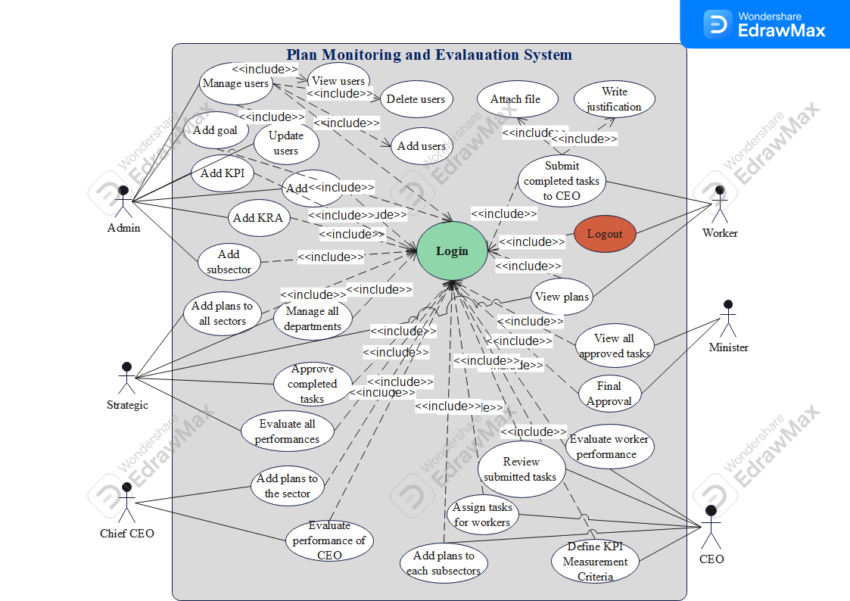
Figure 1: use Case diagram

Class Diagram for the Proposed System
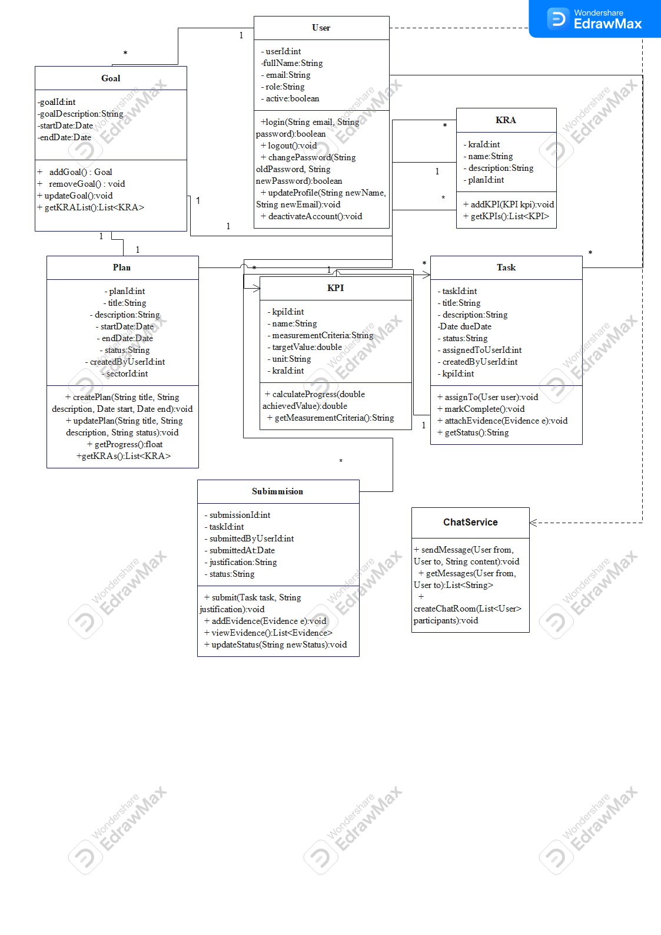
Figure 2: class diagram

ER Diagram for the proposed System
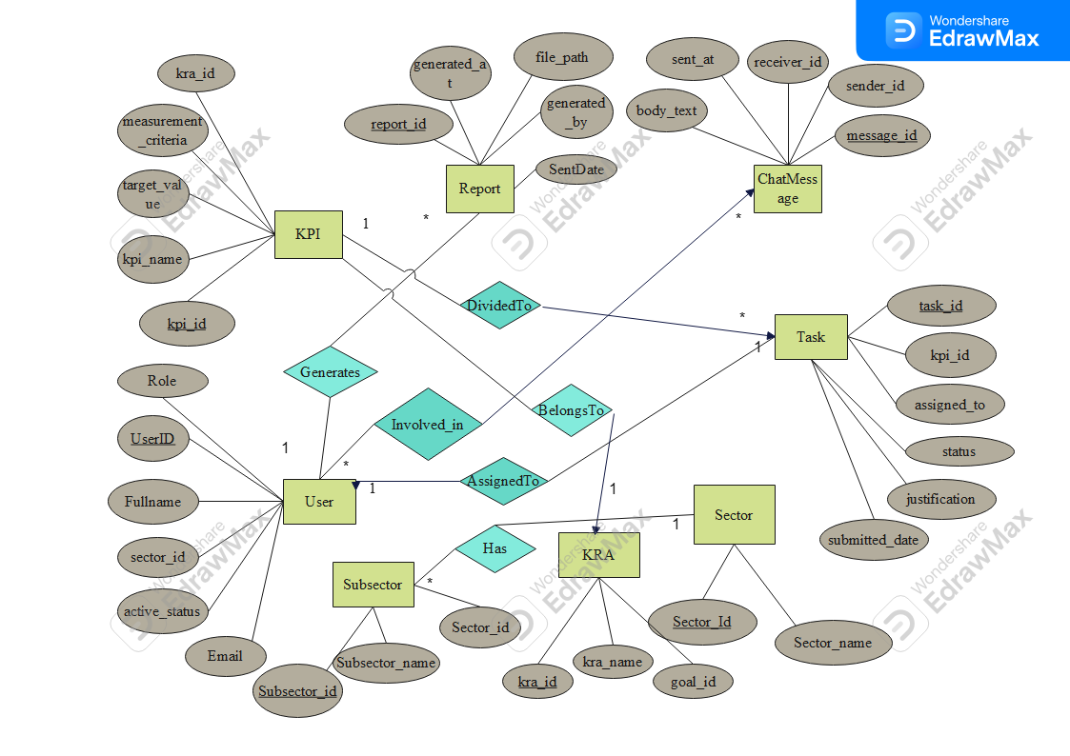
Figure 3: ER Diagram

UI Prototypes
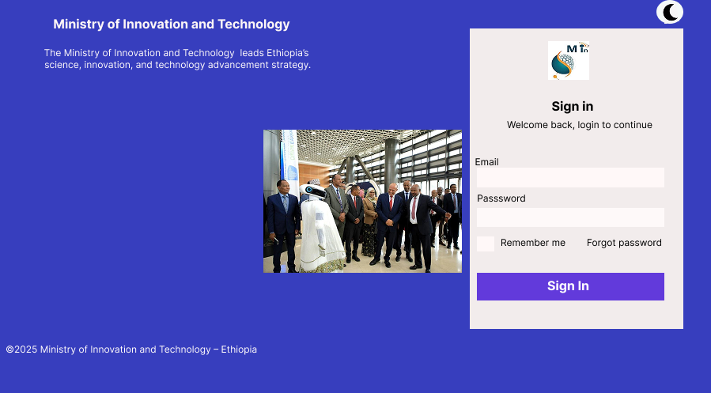

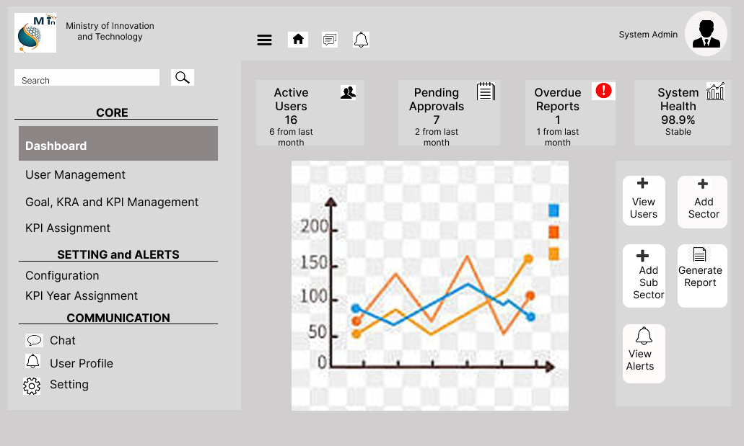

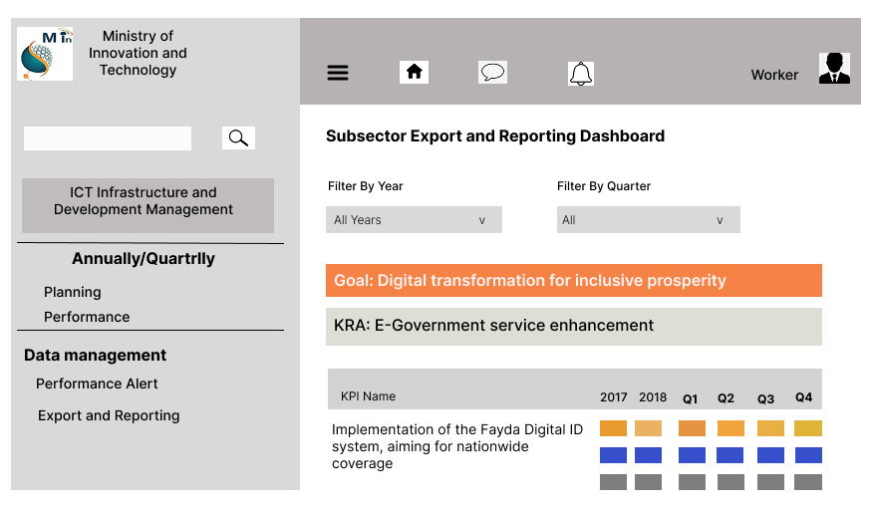

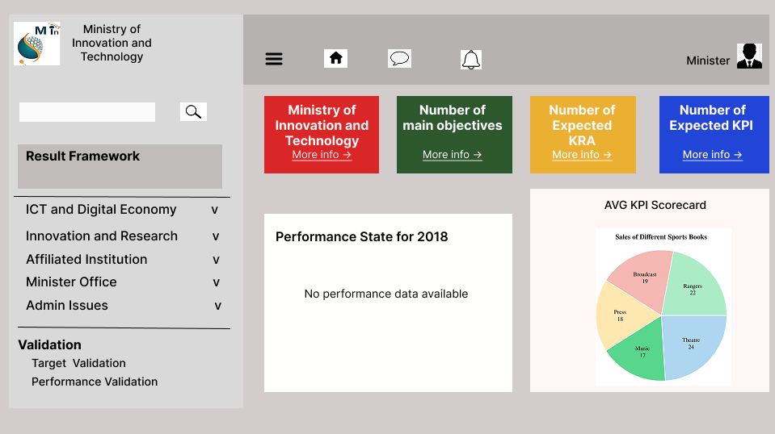

Part Five: General Conclusion and Recommendation

Overall Conclusion of Your Internship Journey
Our four-month internship at the Ethiopian Ministry of Innovation and Technology has been a highly valuable and enriching experience. During this period, we had the opportunity to apply our academic knowledge in a real-world setting and contribute meaningfully to the development of a Plan Monitoring and Evaluation system. This project allowed us to gain practical skills in project planning, data analysis, and evaluation methodologies, while also deepening our understanding of how innovation and technology are managed at a governmental level.
Working closely with professionals in the field, we enhanced our technical competencies, improved our teamwork and communication skills, and learned the importance of aligning technological initiatives with national development goals. The internship not only strengthened our professional abilities but also gave us a clearer perspective on our future career paths.
Overall, this internship was a transformative step in our journey, equipping us with the knowledge, experience, and confidence to take on future challenges in the field of innovation, technology, and public sector development.

Final Recommendations for the Hosting Company and Future Interns
Final Recommendations
For the Hosting Company (Ethiopian Ministry of Innovation and Technology):
- Structured Orientation:
Providing a more detailed orientation at the beginning of the internship would help interns understand departmental roles, ongoing projects, and expectations more clearly.
- Defined Roles and Responsibilities:
Assigning specific tasks and responsibilities early on can enhance productivity and allow interns to contribute more effectively.
- Regular Feedback and Mentorship:
Continuous feedback and mentorship from supervisors would help interns grow both professionally and personally during the internship period.
- Access to Resources:
Ensuring interns have access to the necessary tools, data, and platforms will enable them to perform their tasks efficiently, especially for technical or evaluation-related projects.
- Intern Involvement in Broader Activities:
Including interns in workshops, meetings, and cross-departmental discussions would provide them with a broader perspective on the ministry’s operations and goals.
For Future Interns:
- Be Proactive:
Take initiative to ask questions, propose ideas, and seek tasks even when they are not directly assigned.
- Learn the System Early:
Invest time in understanding the structure and priorities of the Ministry to align your work with its broader objectives.
- Work on Communication Skills:
Effective communication with your team and supervisors is key to making progress and receiving helpful feedback.
- Document Your Work:
Keep a detailed record of the tasks you complete and lessons learned. This will help you when reporting your achievements or reflecting on your growth.
- Stay Curious and Open-Minded:
Use the opportunity to learn not only about your project but also about how public institutions function in the innovation and technology space.

